**Chapter. # 01: Introduction**

**Overview:**

This chapter elaborates the history and case study of xyz well that was abandoned and general overview of plug and abandonment and why well is abandoned after it reaches to its end of life cycle? What are reason behind plugging and abandonment of well? Furthermore, the chapter comprised of the Problem statement, objective and scope of the study.

**1.1 Background:**

The xyz well was drilled in 1990 and came into regular production 2005. In 2007 bottom hole survey job was performed. Well ceased to restrict the flow (observed WHFP drop and no contribution to plant). There was increase in the water cut and decrease in oil production then the re-perforation job was done to change the zone to increase the oil production. After the re-perforation job the well did not produced the expected amount of oil and it was not economical. In 2017, the company decided to plug and abandoned the well.

As soon as an oil or gas well reaches the end of its useful life, when it is no longer economically feasible to produce it or when there are wellbore issues, it is plugged and abandoned. Additionally, the beneficial activity is permanently stopped when oil and gas wells and mature fields are unable to produce hydrocarbons profitably, despite intervention work. This tool can be used with any type of well that has been drilled, including subsea, platform, injection, production, and exploratory wells.

To prevent fluids from moving upward and contaminating nearby formations as water zones condition, production wells that aren't producing or not in use have to be sealed. The plugging technique, which involves putting mechanical or cement plugs in the wellbore at predefined intervals, is used to stop fluid flow. The workover rig and cement poured into the wellbore are necessary to complete this plugging procedure. Depending on how many plugs the well has to be abandoned, the operation can take anywhere between two and seven days. The effort involved in Plug and Abandonment is costly and provides the oil industry with little return on their investment.

A well is killed and permanently closed up by placing barriers, and all of the equipment on the wellhead is removed. This process is known as plug and abandonment (P&A). P&A's primary goal is to eradicate all signs of oil and gas activities and guarantee that hydrocarbon seepages will never endanger the environment. In addition to being expensive and time-consuming, the method does not pay the operators any money. So it would be very appealing if P&A's technology and techniques could be developed to be more efficient and less expensive. But as time goes on, the number of wells that will require permanent abandonment will rise dramatically, necessitating a reconsideration of the technology and approach employed.

**1.2 Introduction:**

The term "permanent P&A" refers to well that has reached its expiry of useful life and will not be in use or re-entered (PP&A). maintaining output at a level that allows for ongoing functioning, or creating the The primary goal for the majority of mature fields is to keep output at a level that can support continuous operation, or to extend the "tail" of the production lifecycle as much as possible. One of the key goals of most established fields is to extend the lifetime.

Cost is the other factor in the economics equation that decides when a field has run its course. Every operational company is concentrating on lowering the regular, ongoing operating costs as well as the capital necessary to keep up output. To keep fields safe and in excellent condition, however, typically necessitates correspondingly growing investments as the wells and facilities that accompany them age.

Due to the growing number of abandoned wells and exhausted fields, the oil and gas industry, particularly the operating corporations, is facing a significant challenge. Before a well may be abandoned, it must first be plugged.

Oil and gas well leakage poses substantial environmental dangers throughout their life cycles, affecting the air quality, groundwater, land, and, eventually, living creatures. Such leak has the potential to contaminate groundwater as well as emit (methane) gas in the environment, causing global warming (Tviet et al., 2020). Leakage from offshore wells has an impact on marine habitats (Rice et al., 2018; Schuot et al., 2019). To have sustainable and risk-free production while reducing remedial procedures, reliable well integrity is required (ISO/TS-16530 2014, Norsok 2013). Furthermore, any freshwater and hydrocarbon bearing regions inside the over-burden should be separated & In order to leave the well in a way that ensures both downhole and surface conditions, the pipes should be cut and pulled to the proper location either below the seabed or at the surface. (Smith and Campbell,v2013). Over hydrocarbon-zones or excessively pressured regions, major regulatory authorities require the installation of 2 separate, permanent well obstacles, as well as one lasting well barrier over nonhydrocarbon bearings. The barriers should be stretched from formation to formation in order to limit vertical and lateral flow while ensuring a permanent sealing (Norsok D-010,. 2013).

Uncountable wells were drilled in United States that weren’t closed until 1950s (Achangv et al.,2020); for example, the forecast of gas emissions in Pennsylvania for 2019 only revealed average methane output of 55600 tons (Ingraffeaa et al.,2020). The United States Environmental Protection Authority calculates that methane leaks up to 6 million tons in the environment each year from natural gas networks (Riddick et al.,2020). The expenses of P&A operation activities, on the other hand considerable, having a low rate of return on expenditure for the companies in charge (Vrlstd et al.,2019). Furthermore, Wellbores with poor P&A create possible leakage routes, demanding expensive re-plugging efforts. As a result, considerable attempts are undertaken for assuring the improved quality and durability of the cement plug in order to close the wells (Abdelalz et al.,2015; Alvi et al.,2020; Kamali et al., 2020; da Silva Araijo et al., 2020; van Oort et al., 2020). When plugging and abandoning a well, various regulatory agencies in the globe having unique regulations, and operators must adhere to the local rules (IEA GHG, 2009). PP&A's shared aim, despite the lack of worldwide standards, is to keep integrity of well in a long-term viewpoint, as mentioned in the Norwegian well integrity standard NORSOK D-10 (2013). Several materials can be utilized as barrier materials if they meet the basic criteria (Oil and Gas Uk, 2012b; Khalifeha et al., 2013; Norsok. D-010, 2013): Ordinary Portland Cement is preferred material in making of permanent well barriers today and in the past, but some other materials could be utilized when they fit for essential characteristics of a barrier substance (Oil and Gas uk., 2012b; Khalifeha et al., 2013);

* Impermeable - prevents hydrocarbons or overpressure fluids from passing past over plug barrier.
* Long-term stability- doesn’t deteriorate with time.
* Non shrinking- there is not any undesired passage between the plugging material and the casing or the annulus.
* Ductile - can withstand mechanical loads, temperature changes, and pressure fluctuations.
* Capable of developing a strong bond with the formation or casing where the barrier is installed.

To reduce subsurface fluid leakage into the environment, plugging and abandoning oil and gas wells (P&A) is becoming more popular. P&A treatments are frequently carried out using cementing. In order to seal the wellbore as it dehydrates and solidifies, this process uses a cement slurry as a barrier. Failure of the cement might result in well failure, hazardous environmental conditions, or even fatalities. Older P&A wells carry risks that operators must assess, and the wells must be properly monitored to limit environmental harm.

Drilling rigs have often been necessary for plug and abandonment. Even while certain rig rates have reduced with a decline in the price of oil, P&A campaigns still expensive. The complexity of manning, mobilising, and maintaining such high-spec rigs, as well as the amount of time needed for them to travel and perform the required job, are the causes of the high rates.

Operators are looking into ways to become more cost-effective while maintaining HSE objectives and requirements in light of the recent reduction in oil prices and growing demand for P&A. New technologies and techniques have been developed as a result, but due to the industry's conservative ideology, many promising alternatives haven't been tested in the field. Even though newer technology will probably play a major role in resolving the P&A dilemma, the standards still need to be evaluated.

The industrial requirement to filling old wells or boreholes would be to recover the hydrogeological properties of the site and avoid contaminates or groundwater bacterial contamination. Plugging and abandonment processes are carried out at the end of a well's useful life to ensure to maintain formation integrity, by correctly plugging wells, to avoid future environmental problems and soil contamination in a cost effective manner by means of CTU.

The presented figure 1.1 depicts a general description of a well before plugging and abandonment.

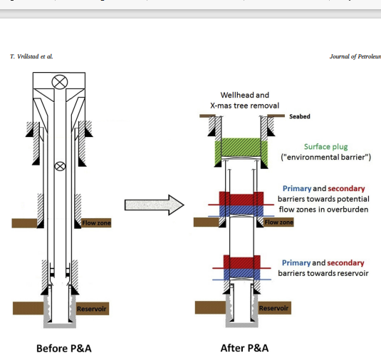

**Figure 1.1 Well before well plug and abandonment**

**1.3 Problem Statement:**

Well integrity after abandonment is a crucial component of plug and abandonment. In the past, not quite enough importance was placed on assuring that wells were adequately sealed, which led to severe oil spills, fluid migration, saline water migration, and environmental difficulties.

**1.4 Objectives:**

1. To identify the potential leaks or cracks in oil gas formation i.e. type, skin etc.
2. To identify zone of abandonment i.e. depth, water could travel up the wellbore and contaminate soil or groundwater

**1.5 Scope:**

industrial requirement to filling old wells or boreholes would be to recover the hydrogeological properties of the site and avoid contaminates or groundwater bacterial contamination. Plugging and abandonment processes are carried out at the end of a well's useful life to ensure to maintain formation integrity, by correctly plugging wells, to avoid future environmental problems and soil contamination in a cost effective manner.

**Chapter. # 02: Literature Review**

**Overview:**

This chapter explains the previous work and some introduction to well abandonment. It contains all earlier and current studies related to this research. In this chapter, appropriate literature about the study are included in aspect. Moreover, literature related to the operational and its environmental impact, well abandonment and practicing in petroleum and exploration are highlighted for safeguard and seepages migration techniques has been included.

**Literatures:**

1. **Mari R. taveit, Mahmoud Khalifeh, Tor Norden, Arild Saasen.** Whenever a well's productive life has come to an end, it is appropriately sealed & discarded. Despite the fact that technological advances and testing approaches are continually being investigated, operational, barrier material, and certification issues all contribute to a higher chance to leak from old or future boreholes. To safeguard the environment, several government regulators have 0% leak acceptability criteria, although naturally hydrocarbons seepages happen on a daily basis all throughout the world. In this work, researchers performed a hypothetical analysis of leaking well and natural seeps, and authors feel that fell analysis is necessary to provide the data needed to analyze leaking wells’ environmental implications. ‘
2. **E. Trudela, M. Bizhania, M. Zarea, I.A Frigaardb.** ‘The authors concentrated on plug and abandon wells in onshore wells, with a concentration on British Columbia (BC). The study looks at regulatory and operational practises, as well as information on BC wells. This dataset is more important since it contains pad drilled unconventional gas wells with large horizontal extent and multistage fracturing (approximately 25000 wells). The older ones, as well as the rest of vertical and deviated well stock, are presently decommissioned. According to the studies, there will be majority of abandonment of wells in the future., as well as increment in the reported surface casing vent flow in pervious time, resulting in growing P&A expenditures.’
3. **Torbjorn Vralstad, Arild Saasen, Erling Fajaer, Jan David Ytreshus, Mahmoud Khalifeha.** The author has dictated that the “plug and abandon wave” particularly in mature offshore location like the North Sea and Gulf of Mexico must be plugged and abandoned because there could be multiple potential leak channels in plugged wells, such as micro annuli, it’s critical to verify that they don’t leak after the abandonment. Permanent barrier should span the whole cross-sections of well to maintain its integrity after abandonment. This includes putting up obstacles in all annuli, which might take a long time and thus be expensive. The difficulties and technology for plug and abandon of offshore wells are reviewed in this study, with keeping an eye on cost efficient solution by establishing permanent well barriers.
4. **Rajs kiran, catalina Teodoriu, Younasa Dadmohammadi, Runnera Nygaard, David Wood, Saeeda Salehi.** Market sentiment, as well as adverse environmental conditions and downhole conditions, made ensuring safer and durable integrity of well conditions immensely challenging. Well stability is crucial throughout the life span among all subsurface wellbores. Wellbore failure has the potential to have significant environmental consequences, including as groundwater pollution, gas escapes in the environment, and fluid leaks and seepage at the ground, in addition to financial consequences. Several researches have concentrated on the well stability issues in various types of unconventional and conventional oil and gas reservoirs. High pressure, high temperature wells, enhanced oil and gas recovery techniques, deep water, water and gas injections, geo-thermal, plugging and abandonment, to name a few, all have their own set of challenges. For understanding main impediments to well stability & what would be needed to sustain it, a comprehensive study encompassing a wide range of topics is critical. Well integrity issues are influenced by a variety of elements that can be classified as chemical, mechanical, or operational in nature. That feature facilitates the creation of zonal isolation, which is required for plugging and abandonment activities. Continuous assessment and monitoring using various logging techniques and testing is required during drilling, completion, and production to resolve concerns that affect the well's robustness. Complex readings of various well logs must be recognized in order to correctly react to a possibly dangerous scenario while de-risking the recurrence of undesirable bottom hole circumstances. Compensating factors for well integrity include pressure, temperature, chemical changes, and corrosion. Temperature or chemical changes, for example, could affect the severity of corrosion, necessitating a complete design and analysis tools to fully appreciate well integrity concerns.
5. **S. Akbari, S.M. Taghavi.** The plug and abandonment procedures can be utilized for the prevention of oil and gas leaks through the hydrocarbon bearing zones to various formations. Cement plugs are commonly employed in P&A operations, are critical in preventing fluids migrations from the reservoir. The dump bailor technique is most adaptive prevalent cement plug (barrier) placement procedures, usually a bailor dumps a predetermined amount of cement over a bridge plug in bottom-hole to change the in situ fluid and also pouring in the wellbore and the annular region outside of bailor. And how the fluid is injected in the wellbore displacing the drilling mud from fluid mechanic’s standpoint. And how the properties should be different form each other. What parameters should be varied for improving efficient originally placed drilling mud removal efficiency.
6. **D.G. aCalvert, MEPTEC, Dallas, TX, and Dwights K. smith;** There are about 600,000 producing wells in the oil business now, after reaching their lifespan all of them will plug. Approximately 1/3 of all well drilled whether oil or gas wells each year are dry, that need to be plugged as part of the abandonment process. Most abandonment plugs aren't verified for their location unless it's required by law, so they're considered to be in the right place. This research examines the most recent approaches of plug and abandoning wells, as well as the best plugging regulations for preserving freshwater horizons. The study looks into problematic areas like poorly sealed & abandoned wells, as well as improper hole-plugging techniques and practices. The materials, procedures, plug testing, and regulatory requirements for plugging and abandoning wells are all discussed in the paper.
7. **“TechnologysSubgroupaof the operations and Environments task group;”.** The basic technology of plugging and abandoning of wells has remained mostly unchanged since 1970. While progress was made in use of chemical additives to change the composition of cement for specific types of wells, majority of wells are still plugged with water based slurry of cement and fluids. Recent shale gas development had revived several plug and abandon issues, such as ancient wells which were never adequately plugged and now pose a risk of contamination or leaking. Furthermore, unprofitable shale gas P&A techniques that are distinct to challenges impacting gas wells, particularly horizontal gas wells, must be phased out in the long term. A shortfall of long term planning and commitment to research that acknowledges economic advantages of P&A in oil and gas activities can be credited for a slow progress in P&A processes.
8. **Mohammadreza Kamali, and Arild Saasen, University of Stavanger; Mahmoud Khalifeh, Laurent Delabroy, Aker BP ASA:** Primary well cementing is used to preserve the well intact by sealing the annular space behind casing, protecting it all from harmful downhole liquids, and keeping it into place. To meet these requirements, the ideal barrier material must last for the duration of the well's life cycle in the wellbore. Several limitations have been discovered and reported by operating companies and scientists over a long period of time. As a result, attempts are being made to develop alternatives to Ordinary Portland Cement (OPC) or to improve the performance of oil well cement. The rheological behavior and short-term mechanical properties of a commercial expansive oil well cement were investigated and compared to neat class G cement as the baseline example in this study. For both cements, the tests were carried out under the same conditions. These tests involve rheology profile characterization, static fluid loss, and the effect of pressure on cement slurries pumping time. In addition, following hardening, the mechanical properties of the cement systems were investigated by evaluating uniaxial compressive strength, nondestructive sonic strength development, indirect tensile strength (Brazilian test), and sample flexibility for up to 14 days. The use of industrial chemicals as an addition enhanced the rheological properties of cement by reducing fluid loss and delaying slurry thickening time in the laboratory.
9. **W, S. White, * MobilsE&P U.S Inc.; Mobil E and P services; J. M. Bakers, Haliburton Logging Services; and D.L. Bours, Haliburton Services.** In the lab, the factors that influence overall appropriate placing of cement and resin plug with potentially better dump bailing method were investigated. The 5 phase analysis comprised of 1. Cementation designing, 2. Visual imagery test, 3. Comprehensive cure plug testing, 4. Shearing bond examination, 5. Gravel packed penetrating test. The results of the test program are presented in this document, together with information on common dump bailer methods and equipment. The use of dump bailers to place cement and resin plugs is recommended. Operators should find this information useful in planning and conducting successful thru-tubing plug backs.
10. **Pedram Fanailoo, David Buchmiller, Simon Ouyang, Eric Allen, and David Buchmiller, DNV GL.** Well must be plugged and abandoned when it reaches a certain stage of its operating life cycle (P&A). The fundamental goal of well P&A is to isolate the substance formations that the wells have penetrated, protecting the environment and upholding safety standards in the process. Well designs, P&A technology and methods, and firm standards all differ significantly from one another. The well's owner must choose the P&A option that minimizes the risk of pore fluids reaching the seafloor and is acceptable to them. In a situation where oil and gas prices are relatively low, finding the right balance between the quantity and kind of well barriers versus the expense of well P&A is difficult. A risk-based strategy to P&A has been created and successfully used to address this difficulty. According to the body of work in which DNV GL has so far been involved, this report summarizes a case study that contrasts a traditional P&A approach to innovative novel methodologies.
11. **Bjarne Aas, Jostien Sorbo, and Sigmund Stokk IRIS/ DrillWell Arild Saasen det Norske Oijeselskep; Rune Godoy Statoil, Oyvind Lunde Conoco Philip and Torbojon Vralsted, SINTEF Petroleum Research/DrillWell.** In the approaching years, thousands of wells offshore Norway must be permanently capped and abandoned. These procedures can be quite costly and time-consuming. Due to the reduction in rig time, leaving the majority of the production tubing in the well may result in financial savings during P&A operations. A key issue with such a method is whether the cement would successfully replace the original fluid due to lack of tube centralization and possibly negative flow dynamics in the annulus Using full-scale experimental studies, we demonstrate in this paper that when the tubing is left in the hole, both with and without control lines, it is feasible to have proper cement placement. Full-scale experiments using both regular and expandable cement have been carried out to determine the annulus cement's sealing ability while tubing is left in the hole. The effectiveness of the cement installation was evaluated using water pressure tests, where leakage rates and pressure dips over the test sections were recorded, and by completing a visual examination after cutting the test assemblies at different positions. The trials demonstrate that, despite the presence of certain micro-annuli, cement is adequately deposited in the annulus when tubing is left in the hole.
12. **Torbjørn Vrålstada , Arild Saasenb , Erling Fjæra , Thomas Øiaa , Jan David Ytrehusa , Mahmoud Khalifeh.** A There will soon be a "wave" of wells that must be permanently abandoned and plugged, especially in established offshore areas like the North Sea and Gulf of Mexico.. As there may be a number of potential leak channels, including microannuli in plugged wells, it is crucial to make sure that wells do not leak after being abandoned. Permanent well barriers must span the whole well's cross section in order to guarantee well integrity following abandonment. That entails installing barriers in each annulus, which might be time-consuming and expensive. The problems and technology for P&A of offshore wells are reviewed in this paper, with a focus on practical, affordable solutions that nonetheless create long-lasting well barriers. Many potential leak pathways and failure mechanisms in permanently sealed and abandoned wells are explored, and cement and other plugging materials are described. Also mentioned are recent technical developments like the P&A barrier made of shale. The particular elements that influence the P&A of subsea wells are also discussed.
13. **Carpenter Chris Reducing Costs of Well Plugging and Abandonment While Verifying Risk j Pet Technol 70 (2018):** Well The creation of a risk-based strategy has been advantageous for well plugging and abandonment (P&A). The recommended strategy is supported by research that permits the modelling of fluid flow via microcracks through a range of downhole component failure modes, the calculation of the environmental effect through dispersion modelling, and identification of the basis for acceptance criteria. The whole study describes how alternative P&A designs may be evaluated using a risk methodology that takes degradation processes, possible flow rates, and environmental effect into account.
14. **Bengt Sola SPE and Dan Daulton SPE, BJ Services:** A The way offshore cementing operations are carried out has been significantly altered by a unique technique. Standard cementing operations in the Norwegian North Sea region generally involve the use of large cement bulk tanks and a batch mixer. The cement mix water is usually created in a mud pit due to the quantity and diversity of additives as well as the base water needed for the slurry design. The industry is given a storable oil well cement slurry that can be kept in a liquid state for more than six months and prepared to set as and when necessary in the cementing process Now, this technology is assisting North Sea operators. Slurries are prepared off-site and evaluated in a lab before being used on site to ensure they meet the exact design specifications..

With the use of Liquid Cement Premix (LCP) technology, plugging and abandoning offshore rigs can be done without the requirement for cement mixing facilities. Additionally, this LCP procedure aids in waste reduction and lessens the negative effects of the cementing process on the environment, human health, and safety.

The method offers fundamental modifications to standard cementing procedures and equipment needs. It also results in immediate cost reductions for employees, equipment mobilisation, and material waste. The decrease of chemical emissions to the ocean has lately gotten increased attention from offshore oil and gas exploration and production activities. Several hundred oil and gas wells are expected to be abandoned in the North Sea over the course of the next year or two. All of these wells will require cement at some point throughout the plugging procedure. Since Portland cement was first used in the oilfield, it has been mixed with water in dry powder form to act as the primary blocking ingredient. The process used to make Portland cement might have a modest impact on the quality of the cement slurries that are used. The process used to make Portland cement can have a little impact on the quality of the cement slurries that are used.In order to stabilise the rig ballast, the cement is frequently moved from one bulk tank onboard to another. This operation will increase the amount of water in the dry cement and alter the characteristics of the final slurry composition. The new method using LCP will raise the slurry's quality and bring down the discharge from cementing operations to zero.

To achieve the zero discharge targets for cementing operations, significant technical developments have been developed and put into practise. For installations without any cement mixing systems or older installations where the cementing mixing systems have not recently been upgraded, the cost of bringing in mobile equipment or, alternatively, installing new equipment that complies with the requirements for zero discharges can be significant and, in most cases, uneconomical..

1. **Taylor Stein, Michael Tunstall, Ben Wellhoefer Halliburton Christian Veillette Enduring Resources Llc**. Over the past 10 years, swellable packer technology has been more widely accepted, and its usage as a productive method for zonal isolation in the oilfield is growing. Now that swellable packers have been used in so many diverse applications, their versatility has been shown in a new light. In order to fulfil this demand in applications including casing repair, liner tieback, corroded casing, and multi-stage fracturing, swellable technology is stepping up to the plate. Swellable packers must provide an anchoring point for the casing or tubing string for these new uses . In order to demonstrate the steps for creating, simulating, and validating swellable-packer anchoring forces that will allow swellable packer technology to be deployed in new oilfield applications, this article will discuss case studies and testing.

This research and data will demonstrate that swellable packer technology can be a workable substitute for cementing casing strings or expanding casing patches for

providing anchoring points and isolation when the application and well circumstances are recognised. Larger IDs are frequently taken into account by this programme, and workover operation expenses are decreased. We'll talk about crucial elements such swelling fluids, pressure needs, production/stimulation situations, well conditions and goals, as well as other engineering and design-related issues. These factors' effects and how crucial they are for developing the swellable packer to fit any oilfield application will be discussed. The outcomes of other job design considerations, such as modelling the behaviour of the swellable packer and carrying out the required laboratory tests to confirm the simulation, will also be contrasted with case study findings.

The paper will finish by discussing the many uses of swellable packer technology that require anchoring pressures.

1. **Thore Andre Stokkeland, Archer; Espen Malde, Per Ove Staveland, Yngve Frøyland, Stian Johnsen Dybvik, John Jacobsen, and Thomas Kibsgaard Vatn, Repsol; Sindre Opedal, Archer:** Over the past ten years, wells around the North Sea have been systematically plugged and abandoned using creeping shale strata as permanent barriers. The Lower Hordaland formation has been qualified as a barrier for the plugging and abandonment of wells in the Gyda Field on the Norwegian Continental Shelf by using an innovative one trip system, which is discussed in this study.

Gyda reservoir, Farsund, lower sgard, and Cretaceous/Tertiary Inflow Group Forties/Lista are the formation groups that need to be segregated in order to permanently plug the wells after the review and integration of data from wells drilled on the Gyda Field.

1. **Lucas Abshire, Stephan Hekelaar and Praful Desai, Schlumberger:** The etheroductive lives are being reached by numerous offshore oil resources across the world. As a result, operas have the potential to block and sandon a sizable number of ear wells.However, the operators and the offshore service providers face difficulties due to the growth of present and future needs. The difficulties necessitating the most thought are as follows:
2. Partial plug and abandonment: Permanently abandoning the well’s bottom while drilling a new well from the top to reach more fruitful targets and maintain usage of the platform’s current infrastructure. Slot recovery programme is the name of the procedure.
3. Local regulatory agencies’ requirements: Depending on the local regulatory jurisdiction, several measures may be necessary to certify offshore wells as permanently abandoned. The North Sea and Gulf of Mexico regulatory bodies are excellent instances of slightly different well abandonment criteria.
4. Combining economics and safety to address the aforementioned two concerns.

The offshore service providers have collaborated with the operators to provide cutting-edge technical solutions that are both financially sound and safety compliant in order to address these difficulties.

For the Norwegian area of the North Sea, a one-trip casing cutting and pulling system that allows for numerous cuts and selective heavy duty spear activation to get around frictional resistance between Caving and the cement or barite has been designed and tested. A casing jack with a million-pound pulling capability has been built just in case. Additionally, field tests for a technology that can mill 150 metres of casing section are now being conducted.

For the Gulf of Mexico, a hydraulically triggered tool can cut up to 72 inch casing has been developed. A single trip cut-and-pull technology has also been applied to deepwater wells. The procedure does away with the need to strip the workstring/BHA equipment once the cut casing is at the surface.

The authors will discuss these technological improvements in terms of new tools and techniques. There will also be field data supplied. Changes are planned in response to the lesson.

1. **Fatemeh Moeinikia**, University of Stavanger and international Research Institute of Stavanger; **Eric P Ford, Hans Petter Lohne ⱷystein Arlid, and Mohammad Mansouri Majoumerd**

, International Research Institute of Stavanger; and **Kjell Kare Fjelde**, University of Stavanger: NORSOK Standard D-010 is being followed in the design of permanent plug and abandonment (P&A) systems on the Norwegian Continental Shelf (NCS) (2013). This is a “fit-for-purpose” risk-based strategy, as opposed to a prescriptive approach to P&A. A risk-based approach means that any given P&A solution is expressed in terms of the leakage risk. This risk can be formulated in terms of the likelihood that the (permanent) barrier system will fail in a specific amount of time and the ensuing environmental leakage that will result.

A straightforward leakage-rate calcula tor has been created in order to quickly assess the leaking potential from a given (permanent) well-barrier solution as part of the process of developing a leakage-risk model for permanently closed and abandoned wells. The second component of the risk-based approach, the consequence in terms of environmental leakage rate, is served by this instrument. This allows for a quantitative evaluation of the well’s leakage potential while accounting for various leakage pathways, such as leaking through cement bulk, cement cracks, and microannuli along cement surfaces.

We will offer models to estimate leakage rates for each leakage pathway in the study and show how to combine them with the leak age calculator to produce a description of leakage flow from the reservoir via breached barriers to the environment. Along with the necessary data and input parameters, this will be covered. Uncertain parameters will be handled probabilistically, allowing the predicted leakage rate to convey uncertainty. The leakage calculator's results will be displayed using fictitious variants of a permanently blocked and abandoned well.

1. **Dean McTiffen, Glenn Tore Iversen, Michael Smalley, and Mohammad Aleemul Haq, Weatherford:** Plug and abandonment (P&A) technologies have gained more global interest in recent years. Increasingly many fields are towards the end of their useful lives. A permanent P&A aims to seal and isolate the well indefinitely. According to reports, the market for permanent P&A has grown to be worth many billions of dollars. Tens of thousands of onshore and offshore wells throughout the world require P&A activities to safely abandon the once-producing asset while adhering to environmental standards and laws. P&A activities do not boost income or asset values, thus almost all operators think that the smallest amount feasible should be allocated to them in the well life cycle plan. This implies that in order to increase production, reduce overall costs, and minimise environmental impact, novel solutions must be developed. environmental impact of P&A activities. The necessity to develop and implement novel downhole technologies arises from the fact that traditional existing technologies frequently fall short of meeting these objectives.

Introduction to well abandonment P&A, well preparation techniques prior to cement plug setting, a brief comparison of various techniques, section milling technology development to dual string, field application on an offshore gas field abandonment campaign, and finally conclusions regarding this novel and developing dual string milling technology will all be covered in this paper.

1. **Fuad Othman, Chooon Hoong Teo, and Faiz Bakri, Sarawak Shell Berhad:** A Subsea wells are abandoned using semi-submersible drilling rigs. Four development wells that exhibited ongoing casing pressure and were packed with horizontal Christmas trees were initially targeted for abandonment. In this article, the plugging and abandonment of each well was divided into four fundamental steps..

* Secure well
* Cut and retrieve Tubing
* Reservoir plug
* Remediation of sustained casing pressure.

The Christmas Tree VX sealing profile must to be clean before the subsea blowout preventer is deployed (BOP). A specially designed wellhead cleaner was created to efficiently clean the VX profile. Caprock restoration was used in order to adequately isolate the zones that may experience flow. Traditional section milling to release the ongoing casing pressure was eliminated using Perforate Wash and Cement (PWC). This technology has been heavily utilised by Shell North Sea, and the operation follows best practises..

In this paper, it is detailed how Dual Casing Cup Type PWC was "first in the world" used to cement across two annuli. Internal Tree Caps (ITC) retrieval utilising the Tubing Hanger Emergency Retrieval Tool (THERT) was shown to be more economical than employing a subsea test tree (SSTT).

The Lower Crown Plug (LCP) design included an erosion plate known as the flow target, which was attached onto the plug by four threads. The tubing hanger received the LCP and was mounted. The flow target from the first well, which is badly jammed above the TR-SCSSSV, may need to be released by milling in order to get access below the TR-SCSSSV..

1. **(C.W.J. Hoyer Dowell Schlumberger Chassagne Elf Aquitaine Norge A.S. B. Vidick Dowell Schlumberger and I.P. Hartley Services Dowell Schlumberger**) Coiled tubing was used in a campaign in the North Sea to permanently abandon wells (CT).This was done in order to comply with the Department of Energy's requirement that the production screens be plugged back in with cement before any well completions were removed. The benefits of employing CT are discussed, along with the operational challenges encountered during cement placement. Also included is a cost comparison with current abandonments using a rig for the full procedure
2. **( B.Chariag, M.Shaheen**)The traditional uses of cementing with coiled tubing, which have been around for the past ten years, are now considered conventional procedures and include zone abandonment, casing repair, water or gas shutoff, and zonal isolation.The application of this technique has been expanded to encompass multizone well testing since it is favourable from a technical and financial stand point.The application of good cement practises through the design and positioning of coiled tubing helps optimise the entire cost of a well testing operation, according to ADCO experience described in this study Accuracy and effectiveness of isolation for cement plugs are described.To demonstrate the associated cost reductions, a comparison between the usage of the coiled tubing approach and the typical zone abandonment method is used in multizone well testing
3. **(T.S. Barry, D.L. Beck, and J.S. Putnam,)** The well histories, production profiles, and decision-making process that led to the choice of coiled tubing cement squeezing over more conventional methods of isolation are all covered in this study. It goes over the equipment setup, step-by-step processes utilised to complete the task, and the preliminary work necessary for proper slurry formulation. Given the friable character of the reservoir sandstone, the research discusses the challenge of sizing the slurry volume. It also emphasises the variations and challenges involved in carrying out the operation offshore as opposed to a comparable land-based activity
4. **(Valentina Rotundo & Jonathan S. Colton (1999)**The design methodology for assessing the serviceability of mechanical designs is presented in this work. With the use of this technique, designers are able to assess the serviceability of complex systems at an early point in the design process. The approach was created in response to the requirement for a tool that takes serviceability concerns associated with the layout problem into account in a three-dimensional context. According to the technique, the designer must define a comprehensive and appropriate description of the components and the service actions that each one requires. It then assesses the overall service. cost for various candidate assembly designs based on the tools needed to do the service operations, their frequency, the time required to perform them, and the access required based on human factors and tool spaces As a case study, the basic method was built utilising Coiled Tubing Units (equipment used by oil-well service companies

**Chapter. # 03: Methodology**

**Overview:**

This chapter explains measures taken before the operation, preparations of well abandonment process, the Plug & Abandonment operational work that relevant to this research. In this chapter, how well is prepared for abandonment, associated field operations with it, placing of cement plugs at surface and subsurface through rig-less operation by the aid of Coiled Tubing Unit (CTU), steps involved in operation to prepare well abandonment according to industrial requirement furthermore material/accessories have been included.

**3.1 The methodology chart.**

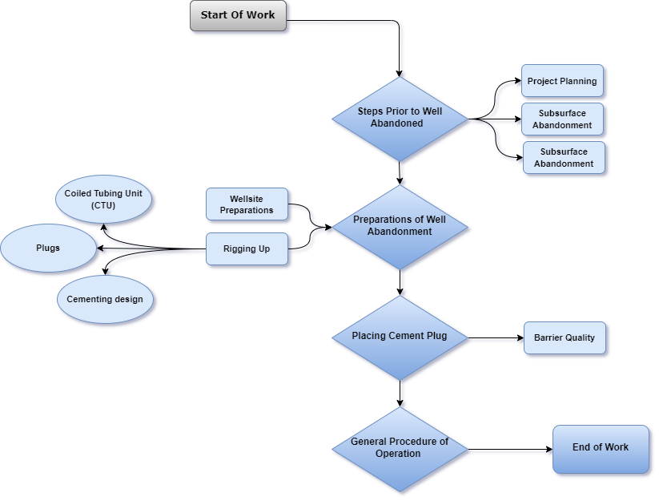

**3.1 Steps Prior to Well Abandoned?**

The well's owner is required to undertake the following things before a well can be abandoned:

* notify all affected landowners of the anticipated abandonment;
* The well's owner is required to undertake the following things before a well can be abandoned:
* make reference to our specifications to make any adjustments required if problems are discovered during the well test. To guarantee that the public and environment are safeguarded before to, during, and after a well is abandoned, businesses must go by our stringent criteria, which are largely outlined in Directive 020: Well Abandonment. The following steps must be finished in general.

**3.1.1 Project Planning:**

A company should design an abandonment program to identify any issues within the well that could lead to potential leaks and to identify all oil or gas formations and all groundwater zones that the well passes through. The company must also evaluate the cement that holds the well in place to ensure that it remains strong and intact.

**3.1.2 Subsurface Abandonment:**

After that, the company must clean the interior of the wellbore to remove any oil or gas that can corrode it or cause the cement plugs that will be inserted within the well to leak. Any wellbore issues identified during the planning phase must be fixed. All oil or gas formations must also be isolated from one another using cement plugs, and any groundwater zones must be segregated from the wellbore in order to prevent any oil, gas, or water from moving up the wellbore and contaminating the soil or groundwater. After that, the business is required to check the well for leaks and refill it with new water or another non-corrosive liquid

**3.1.3 Surface Abandonment:**

The process of abandonment ends with the "cut-and-cap" phase. The Company should cut the well casing to a minimum depth of one metre below the surface and top it with a vented cap, subject to certain exclusions set out in Directive 020. The surface infrastructure of the well must be removed when this phase is complete within a year.

**3.2 Preparations of well abandonments:**

An oil or gas well is blocked and left unattended when it becomes empty or approaches the end of its useful life. These operations entail tasks and work-related activities that put employees in danger. The sections that follow discuss a few dangers that could arise during well plug and abandon operations and provide viable solutions for these risks.

**3.2.1 Well site Preparation:**

preparing for activities relating to the abandonment of the well. Precautions are taken to make working near the well safe. The site is inspected to see if it is secure for entry and exit, the stability and state of the soil, the contour of the terrain, the presence of plants and/or animals, the presence of potentially hazardous atmospheres close to the well, traffic and movement, equipment staging, and other site hazards.

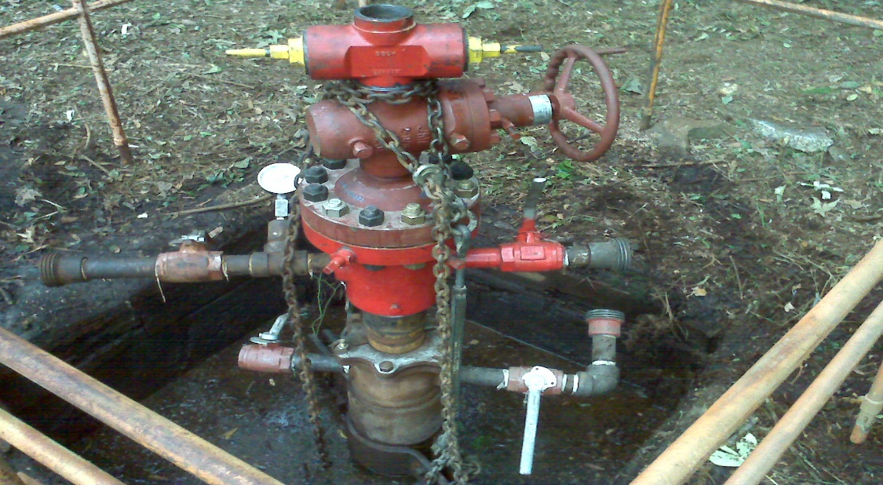

**Fig 3.1: Repaired wellhead prepared for plugging and abandoning**

**3.2.2 Rigging Up (U/P):**

Rigging up include positioning and putting together the various pieces of equipment that make up the rig as well as getting it ready for plug and abandonment.

The safest and most effective way to complete the task should be determined at the pre-job planning phase. When rigging up, the following safety advice should be followed.

• The prevailing wind direction should be taken into account when choosing the direction to put up the rig so that the substructure and engines can be positioned such that engine exhaust is carried away from the rig floor.

• Inspect every piece of machinery that will be involved in setting up the rig. Before using, be sure to thoroughly inspect all rigging equipment (coiled tubing unit).

**3.2.2.1 Coiled Tubing unit:**

Coil tubing units (CTU) are used for such processes; the most common usage of coil tubing is circulation or de-liquification. then clean the hole. CT stands for coiled tubing, which is a continuous length of small-diameter steel pipe and associated surface equipment for pumping fluid at high temperature and high salinity, as well as associated drilling, completion, and workover (or remediation) processes. Coiled tubing oilfield technology was created with the intention of operating on active, producing wells (Rich Christie.,2014). This technology has lately acquired traction among operators for a growing number of workover and drilling applications, as well as its capacity to lower overall costs. The ability of CT to drill or carry tools and equipment in high-angle wellbores is favored by the trend toward extended-reach wells. A coiled tubing unit (CTU) is at the heart of every CT surface operation, with the most visible element being a reel from which a continuous length of flexible steel pipe is spooled. The CT operator spools tubing off the reel and feeds it via a gooseneck, which directs it downhill to an injector head, where it is straightened immediately before entering the borehole. The flexible tubing is drawn out of the well and spooled back onto the reel at the end of the process(Sugar Land.,2014). A high-pressure swivel joint on the storage reel's hub allows fluids to be pumped through the tubing while the reel rotates to spool pipe on or off the reel.

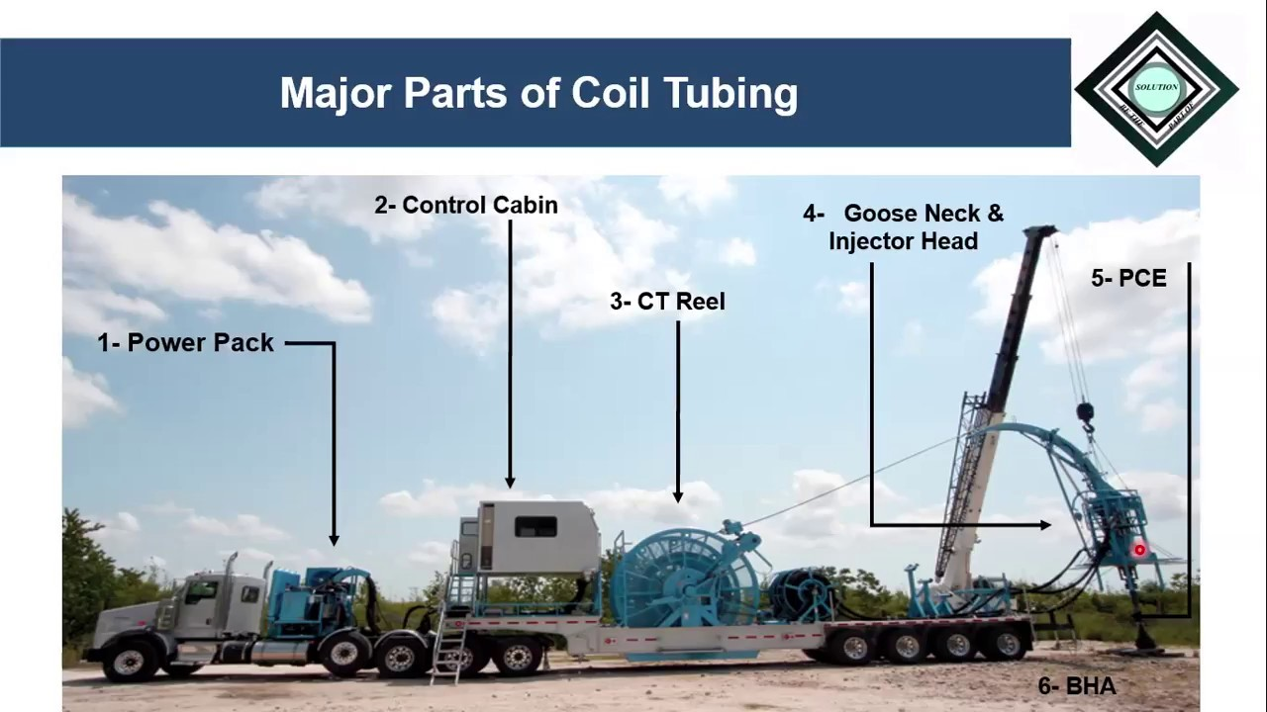

**Fig 3.2: Coil Tubing Unit(CTU)**

**3.2.2.1.1 CONTROL UNIT:**

The control unit is placed behind the coil tubing reel or in a safe location while operating the equipment. The type of operation determines the level of control and instrumentation.

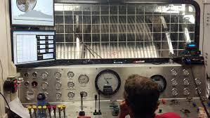

**Fig 3.3: Control Unit**

All of the needed controls for operating a coiled tubing unit from this location are located in the control unit. Behind a coil of tubing reel is typically where a control device is located. The control unit might be moved to a location where the operators will feel secure using the instrument, though, if the environment does not permit this. There are several instruments and gauges for unit operation, and the controls are clearly visible inside the unit. The type of operation determines the degree of control and instrumentation utilized. For example, a simple coiled tubing drilling unit will have less instrumentation than a typical well intervention coiled tubing drilling equipment.

**3.2.2.1.2 POWER PACK UNIT:**

A coiled tubing unit and pressure control equipment are regulated and operated by a power pack unit that provides hydraulic power. In general, the power pack units have a separate source of electric or diesel power.

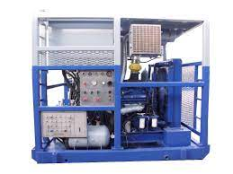

**Fig 3.4: Power Pack Unit**

* + - * 1. **INJECTOR HEAD:**

The injector head which is made up of many hydraulic systems that give the unit a high degree of operational diversity, is one of the most crucial components of a coiled tubing unit.

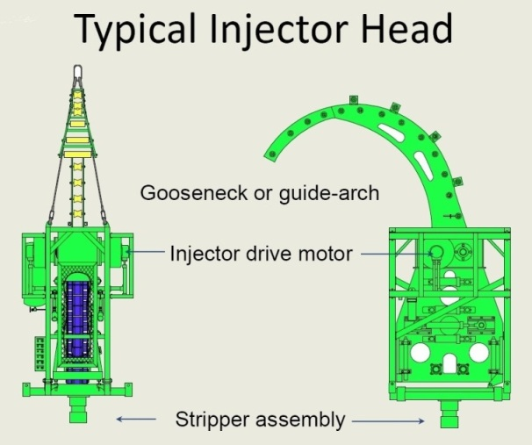

**Fig 3.5: Power Pack Unit**

It serves as the essential pulling and pushing force for a coiled turning to be recovered and ran into and out of a well. When working on a live well, check sure the injector hydraulic pressure is strong enough to push coiled tubing into the well against well bore pressure and that the chain gripper blocks have adequate gripping power to overcome well head pressure.

**3.2.2.1.4 PRESSURE CONTROL EQUIPMENT:**

For coiled tubing devices to operate safely in a live well, pressure control mechanisms for well control must be in place. Three different types of pressure control equipment for coiled tubing units are as follow

* **Primary Barrier:**

A primary barrier is a first pressure containment barrier that is typically closed.

* **Stripper/Packer:**

a significant obstruction in a coil of tubing, is designed to create a pressure seal around a coil of tubing when it is inserted into or removed from a live well.

The stripper/packer is a major barrier in a coiled tubing unit, and it is meant to form a pressure seal around a coiled tubing unit when it is run into or taken out of a Hydraulic pressure is used to activate the sealing mechanism, which is controlled by the operator.

* **Stripper Tandem:**

Tandem stripper assemblies provide a backup stripper in the event that the primary stripper malfunctions or wears out during a coiled tubing operation when used in combination with a fixed stripper.

* **Secondary Barrier:**

A secondary barrier is a mechanical normally open mechanism that is used when the primary barrier fails or degrades.

* **Tertiary Barrier:**

When the primary and secondary barriers fail and the well integrity is severely compromised, a tertiary barrier is a mechanical typically open device that is deployed.

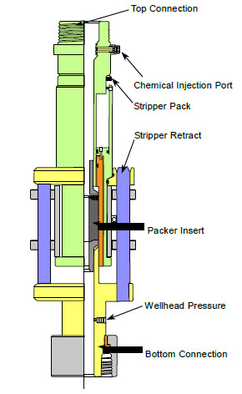

**Fig 3.6: Pressure Control Equipment (PEC)**

**3.2.2.1.5 COIL TUBING BOP:**

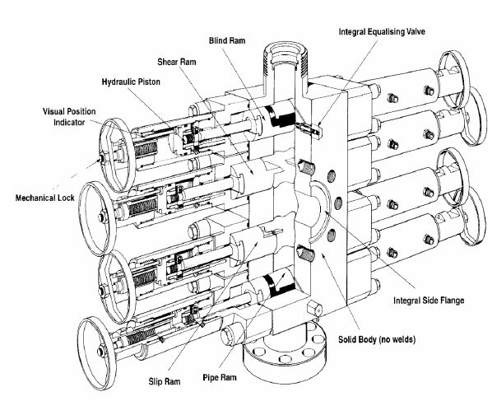Secondary and tertiary barriers are provided by a coiled tubing blowout preventer in addition to the primary barrier system. During regular and emergency scenarios, the BOP is used to secure the coiled tubing and isolate the wellbore pressure. A coiled tubing BOP's usual arrangement includes blind rams, shear rams, slip rams, and pipe rams, as indicated in the diagram.

The BOP features the following rams from top to bottom:

**Fig 3.7: Coiled Tubing Bop**

* **Blind Rams:**

Blind rams are used to close and seal a wellbore without the use of coiled tubing or any instruments.

* **Shear Rams:**

Shear rams are intended to cut coiled tubing in an emergency, but they do not seal the rams.

* **Slip Rams:**

Slip rams are meant to close over coiled tubing and hold it in place regardless of whether well forces operate up or down, but they are not seal rams.

* **Pipe Rams:**

Pipe rams are meant to seal around an annular area and shut around coiled tubing.

**3.2.2.1.6** **COILED TUBING REEL:**

The main use of a coiled tubing reel is to store coiled tubing. The coiled tube reel is frequently hydraulically driven, either directly or by a chain. A reel-driven system is created to maintain the coiled tubing in a dynamic tension between the gooseneck and the reel while it is being unspooled and respooled.

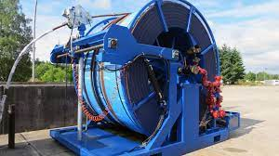

**Fig 3.7: Power Pack Unit**

Coiled tubing capacity is determined by a number of criteria, including the size, weight, and length of the tubing, as well as the availability of a footprint. It is critical to choose coiled tubing that is appropriate for the intended function. For some offshore areas, overcapacity coiled tubing can result in high costs and limited space. However, a coiled tubing unit with insufficient capacity can cause problems.

**3.2.2.1.7 Coiled Tubing Method:**

Long, continuous pipe wound around a spool called coiled tubing. Before being driven into the wellbore, the pipe is straightened, and then it is wound again to recoil the pipe back onto the transport and storage spool. Coiled tubing can be as long as 15,000 feet or more, depending on the spool size and pipe diameter. In the early 1980s, coiled tubing for corrective cementing was first used. Since then, the method has drawn a lot of interest. This method has proven to be particularly cost-effective for applying small amounts of cement slurries needed to cure channelling behind tubulars, block off perforations, press cement into perforations, cure lost circulation zones during drilling, etc and setting whipstocks in cement. It is a cost-effective technology since the pipe is continuous, minimising the difficulties of creating connections and the need for a typical rig. However, various issues, such as fatigue issues, hole cleaning, unique cement slurry design, unit area and capacity, crane capacity, and local legislation, limit the usage of coiled tubing for cement plug installation.

* **Fatigue problems**—Coiled As the diameter of the coiled tubing rises for cementing applications, fatigue life of the coiled tubing is a significant area of concern. The coiled tubing is stressed each time it is spooled on and off the reel and over the gooseneck of the coiled tubing machine. Larger diameter coiled tubing raises the most serious safety concerns. The internal pressure created by bending and straightening the coiled tubing is another factor. Coiled tubing lifetime prediction models have been created in order to forecast the coiled tubing qualities because there is no feasible non-destructive way to measure the degree of damage buildup. cleaning the holes The efficacy of hole cleaning in big hole diameters is decreased by limited flow capacity caused by the size of the coiled tubing and a lack of mechanical agitation effects through pipe rotation.
* **Unit space and capacity**—

The unit deck space for locating the coiled tubing equipment, such as the reel, injector, pumping equipment, cementing equipment, and testing equipment, needs to be evaluated while evaluating the viability of coiled tubing for cementing. Additionally, the construction of the unit must be able to support the weight of the equipment without failing. The soil and surrounding region should be able to support the weight for on-land wells, and for offshore wells, the weight of the drilling platform, drillship, vessel, semi-submersible, or other working units must be taken into account. The size and capacity of pipe handling equipment (such as injector heads, reels, well control equipment, etc.) and capacity need special attention because cementing with a coiled tubing unit necessitates higher pipe diameters. have to be increased. Therefore, the unit space

* **Local regulations**—

The goal of regulations is to carry out a safe coiled tubing operation, which calls for coiled tubing quality control, wellsite safety standards, and safe tool deployment into and out of the well. One of the primary areas that local regulators are concentrating on is well control equipment (such as BOPs), pressure rating of coiled tubing, fatigue prediction, unit capacity, and crane capacity. However, the standards used by various regulatory bodies vary. Designing a cement slurry— A typical main cement recipe is not the same as a standard coiled tubing cement recipe since drillpipe has a higher flow capacity than coil tubing. Coiled tubing's energy for mixing with the cement slurry caused a mechanical acceleration. Consequently, a common cement slurry intended for application with coiled tubing has a longer thickening time, and lower viscosity and yield stress

* **SIGNIFICANT ADVANTAGES:**

The use of CT tools and methods has a variety of benefits over conventional drilling and workover methods. Fewer workers, a less environmental impact, quick mobilisation and rig-up, and time savings associated with pipe handling while running into and out of the hole are just a few advantages. Such abilities are critical in wellbores with a high or deep angle. Coiled tubing can assist the operator avoid the risk of formation damage that comes with dying a well by allowing sustained circulation during well intervention procedures. Comparing these advantages to conventional drilling or workover methods could result in significant cost savings.

**3.2.2.1.8 Gauge Cutter**

The Gauge Cutter was created to remove scale, debris, paraffin wax, and other things in addition to drifting the tubing string.

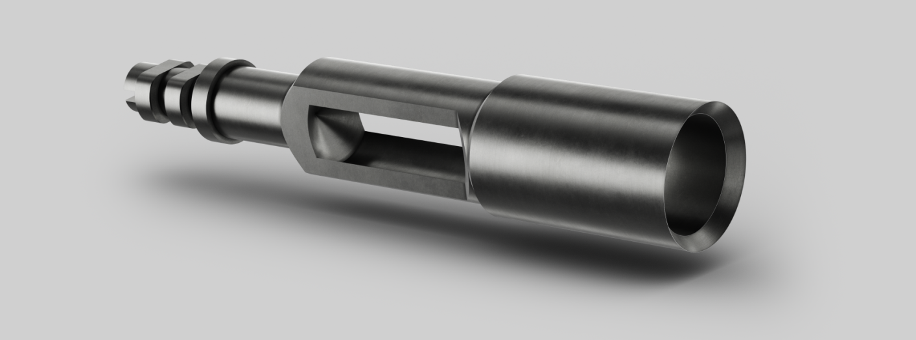

**Fig 3.8: Power Pack Unit**

Reaching Prior to carrying out more difficult procedures like recovering or installing flow control devices, the Gauge Cutter must reach the specified depth to certify that the tubing string is clean.

* **Applications**

mostly used for drifting the tube but also intended for cleaning paraffin wax, scale, and other debris.

* **Features & Benefits**
* Available in a variety of sizes, with different lengths and diameters upon request
* On request, a saw-tooth design is available.
* On request, a tapered design is available.

**3.2.2.2 Plug**:

A plug is any item or equipment used within the wellbore to close off a hole or passageway. Plugs are often divided into two categories in the context of petroleum engineering: mechanical plugs and non-mechanical plugs. Permanent plugging materials will be thoroughly covered in the discussion of non-mechanical plugs (see Chap. 4). Common names for mechanical plugs include "bridge plugs" and "mechanical plugs."

* **Bridge or Mechanical**

Plugs Bridge plugs are mechanical devices that are inserted and utilized to create a seal inside production tubing or casing. There are three types of bridge plugs: permanent, retrievable, and repositionable. An intact removal from the conduit is not a design characteristic of a permanent bridge plug. A significant destruction process is required for its removal. A retrievable bridge plug, however, has a characteristic that makes it easier to remove it from the conduit whole. A repositionable bridge plug has a design element that makes it simple to move it inside the conduit (without removing it) while maintaining its original function. A deep-set bridge plug can be utilized as a WBE for temporary abandonment throughout the abandonment process. They make plug retrieval simpler and faster. However, due to worries about the long-term endurance of mechanical plugs, their use as a WBE during permanent abandonment should be avoided. To reduce the risk of contamination during setting materials (such as Portland cement, thermosetting polymers, geo polymers, etc.), mechanical plugs can be employed to create a foundation.

**3.2.2.3 Cementing:**

Zone isolation is the main goal of primary cementing. When crucial sites are located in the annulus around the casing or in the open hole beneath the casing string, a slurry of cement, cement additives, and water is mixed and pumped through the casing to those locations.

**3.2.2.3.1 Cement DESIGN**

list I'll outline some of the most important factors on which you should concentrate when creating a P&A job that uses cement via coiled tubing and point out the areas where it differs from the typical job design.

**3.2.2.3.2 Temperature**

The wellbore hardly ever cools down due to the tiny flow regions and pumping rates associated with coiled tubing. Therefore, using the bottom hole static temperature (BHST) rather than the circulation temperature (BHCT), as recommended by API normal testing protocols, is one option to modify the circumstances to reflect the ones that actually exist in the wellbore.

* + - * 1. **Rheology**

Giving Fluid friction is always an issue when pumping through coiled tubing due to the narrow crossflow areas of a CT string and its length (which the slurry will have to go through regardless of the depth of application for the plug). Engineers strive for cement slurries with the lowest viscosity feasible to lower friction pressures. Recommendations for acceptable rheology’s are frequently stated in terms of yield point and plastic viscosity since cement slurries typically behave as Bingham plastic fluids. Which are:

Yield Point should be from 5 lbf/100 sqft to 10 lbf/100 sqft

Plastic Viscosity should be below 50 cP

### Furthermore, it is advised to observe linear-plateau trends in the consistency during thickening time tests as well as to have no gel development within the first two hours at BHST (verifiable via remoter tests), as some cementing operations may require the CT to remain inside a column of cement for an extended period of time. Any sign of early gelation in consistometer graphs has to be highlighted and handled.

### **Free Water / Settling**

No settled solids or free fluid are allowed in CT slurries. Both events could have severe effects on the integrity of the slurry inside the CT reel, resulting in pipe clogging or worse. Regardless of the circumstances, free water testing should result in zero. It is permitted for slurry density to vary from top to bottom by no more than 0.5 ppg.

### **Fluid Loss**

In order to prevent the slurry from becoming prematurely dehydrated while being pumped through the CT, proper fluid loss is necessary. This is because the smaller cross-sectional areas of the coiled tubing result in higher pumping friction pressures. If there is a squeeze involved in the plug action, it becomes of the utmost importance. In order to allow good quality cement slurry and not the slurry aqueous phase to flow past the injection point, the fluid loss must therefore be carefully balanced against the injectivity rate attained. As a general rule, fluid loss is tighter (lower) the lower the injectivity. A common guideline for fluid loss is to maintain it under the 50 cc/30-minute threshold..

### **Thickening Time**

When developing CT cement operations, the thickening time selection is frequently evaluated from a different perspective because the repercussions of a premature cement set, related asset damage and downtime, would be substantially harsher than a similar instance using conventional tubing. There are many common sense guidelines to choose the proper pumping time for these kinds of jobs that may be found all throughout the world. All of these guidelines are conservative. Here are a few instances that we have come across:

• Minimum thickening time of 8 hours

• At least 5 to 6 hours, or an additional 3 hours over the period of employment.

• The placement time multiplied by two plus a safety factor.

Generally speaking, we advise a minimum thickening time of six hours. However, what matters more is that these tests are carried out under conditions that are as similar as feasible to those of the job:

For however long it would take to batch mix the cement, condition the slurry at surface pressure and temperature (plus any additional temperature gained as a result of mixing equipment shearing).

* When calculating placement, use the lowest pumping rate that can be reasonably anticipated given the project requirements.
* Verify the heating ramp connects to the BHST
* Allow at least a few hours of safety time..

In CT cement operations, there is very little chance of contamination. Additionally, there is very little room for mistake when establishing the downhole temperature with the BHST because there is very little cooling. Therefore, assuming Waiting-on-cement (WOC), as specified by the compressive strength development charts of the non-contaminated slurry, the operation after the cement is set may be scheduled with extremely high precision. Therefore, whatever safety margin is imposed on pumpability won't have a materially negative impact on any other components of the operation. Therefore, it is wise to choose a lengthy thickening time to be safe rather than sorry.

### **Slurry mixing**

The cement slurry should always be batch mixed to achieve uniform slurry qualities (density, additives dispersion, etc.).

Several broad guidelines from our "Guidelines to Set Cement Plugs"—which, if you haven't read it yet, I strongly advise you do—remain valid throughout CT deployments:

• You must continue to examine the characteristics of your well fluid and pre- and post-flushes and make the necessary adjustments.

• To position the plug and prevent the slurry from falling into the wellbore below due to gravity, you still need a rigid base. However, the spotting method described above aids in reducing the "jetting effect's" influence and minimises the relevance of the viscous pill.

These recommendations for conventional operations lack or lose validity in CT applications:

* The 500 ft rule of thumb don’t apply anymore, as this length accounts for contaminated cement on top and bottom, which will be smaller in CT deployments. CT could accommodate smaller plugs.
* CT is the slimmest assembly that one could find; the disturbance created by the CT while POOH inside the cement plug is negligible. However, POOH speed matching pump rates during the spotting techniques must be observed. Spotting allows plugs longer than 500 ft to be placed at one run.

• While still an option, foam balls and darts are no longer strictly necessary. The CT string has much less contamination than tubing/drill pipe assemblies, and the deployment technique may deviate from conventional balance plug techniques.

We have well exceeded the amount of lines we desire in a single piece, but coiled tubing cementing is a topic in and of itself that merits more discussion. In my upcoming blog post, I'll collaborate with a well-known expert in CT field operations to examine CT applications for well integrity (Squeezes and Plugs) from the perspective of a tubber.

We'll talk soon.

**3.3 Placing Cement Plugs:**

There are various techniques for inserting cement plugs inside wellbores, and Daccord et al. have provided an overview of these techniques (2006). The balanced plug technique, in which cement is pumped through the work string and set at the desired depth, is the most widely utilised. However, it can be difficult to implement placing good cement plugs

To stop fluids from migrating between the various formations, cement plugs are inserted into the borehole. Additionally, this stops fluids or gases from rising to the surface. Preventing cement from flowing deeper into the well during cement plug installation is essential to avoid instability of the lower interface with the fluid below due to variations in density or viscosity (Calvert et al., 1995; Craw shaw and Frigaard, 1999; Malekmohammadi et al., 2010). Rayleigh-Taylor instability is the term used to describe this occurrence. To ensure proper installation of the cement plug, a solid basis or foundation is consequently essential

Pressure testing is done after the plugs have been installed to make sure they are tight. If liquid releases take place, they will be visible surrounding the plug. Additional tests may involve air monitoring above the plug for hydrocarbon gas and/or vapour emissions. When carrying out well abandonment-related plugging activities, state and federal requirements should be examined and followed.

* + 1. **Well barrier:**

Well Barrier Illustration of a well-bearing wall The function of well barriers in stopping or responding to well leakages. The plug itself must seal the wellbore and maintain its integrity over time in order for the goal of "restoring the cap rock" to be achieved. The following traits of permanent well barrier materials are listed in NORSOK D-010 (2013), and Oil & Gas UK (2015b) also provides a similar list:

maintain integrity over time

* Impermeable
* Non-shrinking,
* Capable to bear impacts and mechanical load
* Resistant to chemicals and substances (H2S, CO2, and hydrocarbons);

ensure bonding to steel; and not detrimental to the integrity of steel tubular Since cement is utilized in the majority of plugging procedures, it is assumed for simplicity's sake that cement is used as a plugging material in this section. The majority of the subject, but, also applies to other plugging materials. Since cement is utilised in the majority of plugging procedures, it is assumed for simplicity's sake that cement is used as a plugging material in this section. The majority of the subject, but, also applies to other plugging materials.

The wellbore plug may have potential leaks that can happen through it or around it. The permeability of the plugging material is the main factor in determining leakages through the plug. Due to down hole circumstances chemical and thermal degradation of the plugging material may affect the plug integrity and may increase the leak rate through the plug. While leaks around the plug occur in so called micro annuli which are the spaces between the plug and casing (or formation), and may be produced by de bonding as a result of shrinkage during cement curing or by poor mud removal during plug placement.

## **3.3.1.1 Durability of cement at down hole conditions**

The wellbore plugging material must be unaffected by the ambient downhole conditions in order for the plugs to maintain their sealing capacity over time. In other words, neither heat nor chemical degradation should occur with the plugging material. Common downhole substances that could be harmful include CO2, H2S, and hydrocarbons, but since water (also known as brine) is typically present downhole all the time, it should also be added to this list. Controlled laboratory ageing experiments can be used to measure the durability of blocking materials like cement, but as Zhang and Bachu (2011) have noted, the precise test circumstances can significantly affect the outcomes. Therefore, care should be given when creating a test procedure. for ageing tests, and Oil & Gas UK (2015c) has suggested a guideline on how to perform durability tests of plugging materials.

**3.4 Steps Involved in Operations**

Although well geometry, well-completion design, and depth caused variations in individual well characteristics, a standard set of operations was established for the CT campaign.

**3.4.1 Drift Wash**

* Run 1 Drift wash with rotating nozzle

**3.4.2 Perforation.**

* Run 2 First punch run (establish annular circulation)

**3.4.3 Washing.**

* Run 3: Wash run with fluidic oscillator
* High-rate annular flush
* Pump wettability spacer
* High-rate tubing flush

**3.4.4 Cementing.**

* Run 4: Cementing run (base)
* Run 5: Cement plug
  + 1. **Verification.**
* Pressure tested cement plugs at suited pressure for specific test(minutes).
* These runs would be supplemented by additional runs for scale milling, acid spotting, fishing, and CCL runs, as necessary.

**3.4.6 Case Study of XYZ Well:**

|  |  |  |
| --- | --- | --- |
| **Well XYZ** | | |
| Year | Date | History |
| 1990 | 16/10/1990 | Completion |
| 2005 | 16/09/2005 | Regular Production |
| 2007 | 09/08/2008 | BHP |
|  | | Well Cease to flow (observed WHFP drop and no contribution to plant) |
| 2011 | 04/11/2011 | Re-perforation |
| 29/11/2011 | After Re-perforation, Well did not flow |
| 2017 | 27/04/2017 | P&A |

**Table 3.1: Xyz Well Details**

**Sequence of operations:**

In the following general procedure for P&A operation will be described. The main steps outlined in packer the following are

**Plug and Abandonment – XYZ-Well L.S and S.S (RIGLESS)**

|  |  |
| --- | --- |
| Pref. interval | : 2648-2692 = 8.0 M (Long String) |
|  | : 2440-2445 = 5.0 M (Short String) |
|  | : 2385-2387.5 = 2.5 M (Short String) |
| Formation | : Lower Goru |
| PBTD | : 2715 M (Long String) & 2669.5 M (Short String) packer |
| 7” casing | : 0 – 2905 M |
| 7” Packer | : 2669.5 |
| Minimum ID | : 49 mm (Long String) & 47 mm (Short String) |
| EOT | : 2684 M (Long String) & 2363 M (Short String) |

|  |  |  |
| --- | --- | --- |
| DATE  dd-mm-yyyy | Duration  (hours) | Sequence of Operation |
| 20/04/2017 | 13 | Abc Coiled Tubing Unit(CTU), Cementing and slickline mobilized to the well xyz field.  Held pre-job safety meeting and discussed.  **Rigging up.**   * abc Coiled Tubing Unit(CTU), Cementing and slickline spotted and rigged up surface high pressure surface lines.   **Slickline drift**  **Long String**   * Slickline rigged up pressure control equipment on X-mass tree. * Pressure tested Pressure control equipment(PEC) at 3000 psi for 10 minutes. * Pull out of hole(POOH) to surface and swapped to Surface safety valve (S.S). |
| 21/04/2017 | 13 | **Short String**   * Rigged up Slick line and RIH with 1.75" gauge cutter and tagged at 2636M. * End of tubing(EOT) = 2362 * Perforation = 2440-2445   PBTD=2669   * 4 Upper Master Value * Pull out of hole (POOH) Downhole Slick line(DSL) |
| 22/04/2017 | 24 | **First Cement Plug (2751 M up to 2684 M)=67 M (Long String)**   * CTU installed BOP on top of X-mass Tree. * Stabbed CT in IH. Pulled test the connector to 15,000lbs. * Drifted 0.625" ball thru CT. Installed Cement (full-bore) nozzle. * Rigged up IH on top of BOP. Closed pipe rams and pressure tested pipe rams to 4000 psi for 10 minutes. Good test. * CTU commenced RIH while trickling with water at 0.4 bpm (observed excessive drag and over-pull of 12000lbs. Max safe limits of CT) from 2350 to 2610 M. * Unable to reach Target Depth of 2751M, therefore placed cement plug at depth 2500m. * Pumped 3bbls spacer followed by 10bbls of cement slurry displaced with CT volume while CT stationed at 2500M. * POOH CT without any overpull/drag to safe depth 2270m. Completed 2x bottoms up (46bbls). Observed cement contamination at returns followed by clean water. * Commenced CT POOH to surface while trickling with fresh water @ 0.5bpm * WOC for next 24hrs |
| 23/04/2017 | 18 | * Cont. WOC to complete |
| 06 | * R/Up DSL and RIH with 1.75" gauge cutter, tagged top of cement at * 2574.5m. POOH DSL and R/down * Hooked up Well head and pumping unit connection. Pressure tested cement plug at 500psi for 15min. Observed good test. R/down pumping unit lines. |
| 24/04/2017 | 24 | **2nd Cement Plug (2669.5-2385-284.5m) (Short String)**   * After rectification of X-mass tree wing valve problem, R/U M/S SIb CT and started RIH with trickling fresh water @0.5bmp rate down to 2669.5m * Conducted pressure test at 150psi. Observed pressure hold (no objectivity/loss). Completed one (01) completed bottoms up. * Observed well for 05hrs. |
| 25/04/2017 | 21 | * Observed well cont. * Mixed 15.8ppg cement slurry. * Pumped 3bbls of spaced followed by 31bbls of 15.8ppg slurry at the rate of 0.6bpm, while maintaining POOH speed to nozzle out complete cement slurry as CT reached 2385m. * Completed 2x completed bottoms up while back pressure maintained around 100-150psi. POOH CT |
| 03 | * WOC for 24 hrs |
| 26/04/2017 | 24 | * Completed WOC 24hrs * R/U DSL & RIH with 1.6" GC. tagged cement top at 2275m. POOH DSL and lay down (Cementing Unt R/up CMT line and pressure tested plug cement at 500psi for 15min. Observed good test.   **3rd/4th cement plug Short/Long Cement plug**   * Prepared tubing puncture equipment (mechanical) * H/up PCE along with DSL for SS. * RIH DSL with 1.78" puncture tool down to 150m and punctured SS. * Switched DSL assembly to LS and RIH down to 100m, punctured LS.   (confirmed tubing puncture by pumping fresh water through tubing and observed returns via TCA for each string)   * Prepared 15bbls of cement slurry (class G) of 15.8ppg. * Circulated fresh water by bull heading and observed clean returns at pit. * Pumped 05bbls cement slurry and displaced with 1.3bbls fresh water, placed top cement plug (short string) at depth 100-150m. * Switched to long string and pumped fresh water. * Bull headed 05bbls cement slurry and displaced it with 0.63Bbls of fresh water, placed top cement plug (long string) at depth 50-100m. * R/down CMT unit and closed master valve   WOC both plugs for 24hrs. |
| 27/04/2017 | 09 | **Slick Line Tag TOC**   * Slick line RIH with 1.75" gauge cutter and tagged top of cement plug * Long String at 23M. POOH to surface Switched DSL assembly to Short String * DSL RIH with 1.75" gauge cutter and tagged top of cement plug Long String at 35M. POOH to surface and rigged down.   **Pressure test of First Cement Plug**   * Pressure tested cement plugs to 500 psi for 10 minutes. Good test.   **End of Cement Plugs**  Released the equipment for next well at 1000 hrs on 27-04-2021.  **Note:**  Recovery of Tubing head spool along with complete wellhead (casing/drilling head spool) and welding of abandonment plate on the top of surface casing is pending, and will be carried out by ABC team (Service company) in one go of P&A wells after completing cement plugs. |

**Table 3.2: Sequence of Operations**

**Chapter No.# 4: Result and Discussion:**

The xyz well was drilled in 1990 and came into regular production 2005. In 2007 bottom hole survey job was performed. Well ceased to restrict the flow (observed WHFP drop and no contribution to plant). There was increase in the water cut and decrease in oil production then the re-perforation job was done to change the zone to increase the oil production. After the re-perforation job the well did not produced the expected amount of oil and it was not economical. In 2017, the company decided to plug and abandoned the well.

As soon as an oil or gas well reaches the end of its life when it is no longer economically feasible to produce it or when there are wellbore issues, it is plugged and abandoned. Additionally, the beneficial activity is permanently stopped when oil and gas wells and mature fields are unable to produce hydrocarbons profitably, despite intervention work. This tool can be used with any type of well that has been drilled, including subsea, platform, injection, production, and exploratory wells.

To prevent fluids from moving upward and contaminating nearby formations as water zones condition, production wells that aren't producing or not in use have to be sealed. The plugging technique, which involves putting mechanical or cement plugs in the wellbore at predefined intervals, is used to stop fluid flow. The workover rig and cement poured into the wellbore are necessary to complete this plugging procedure. Depending on how many plugs the well has to be abandoned, the operation can take anywhere between two and seven days. The effort involved in Plug and Abandonment is costly and provides the oil industry with little return on their investment.

A well is killed and permanently closed up by placing barriers, and all of the equipment on the wellhead is removed. This process is known as plug and abandonment (P&A). P&A's primary goal is to eradicate all signs of oil and gas activities and guarantee that hydrocarbon seepages will never endanger the environment. In addition to being expensive and time-consuming, the method does not pay the operators any money. So it would be very appealing if P&A's technology and techniques could be developed to be more efficient and less expensive. But as time goes on, the number of wells that will require permanent abandonment will rise dramatically, necessitating a reconsideration of the technology and approach employed.

**4.1 Well Abandonment phases classify as,**

‘Generally, Plug and Abandonment operations might be categorized in 3 phases

* Phase 1. ------------------Reservoir Abandonment
* Phase 2. ------------------ Intermediate Abandonment
* Phase 3. ------------------Wellhead and conductor removing.

Have divided into the operational sequence of plug and abandonment operations into mainly three phases

**Phase1** is defined as the reservoir abandonment and includes installing primary and secondary barriers towards the reservoir

**Phase2** is defined as the intermediate abandonment and includes installing potential barriers towards flow zones in the overburden and surface plug

**Phase3** is referred to as the cutting and recovery of the casing strings and conductor as well as the removal of the wellhead and conductor Some authors have suggested a fourth step, called phase 0 preliminary work, in addition to these three. This phase involves pre P&A work including dying the well and placing deep set mechanical plugs. Table 1 summarizes the contents of each of these steps of the plug and abandonment operation.

A concept of well integrity is essentially focused on ensuring well control through adequate well barriers to manage the well. At each point of a well's lifespan, two qualified independent well barrier envelopes should be installed. The two-barrier theory takes into account two separate well-barrier envelopes: primary and secondary. The primary well barrier is the earliest defense against inflow from a probable source. The secondary well barrier is a supplementary barrier which also restricts input from a potential source. The secondary well barrier serves as a backup to the primary well barrier and is typically only used if the first well barrier fails. The principle of two barrier philosophy has shown in figure 6; primary well barrier represented by blue line and secondary barrier in red.’

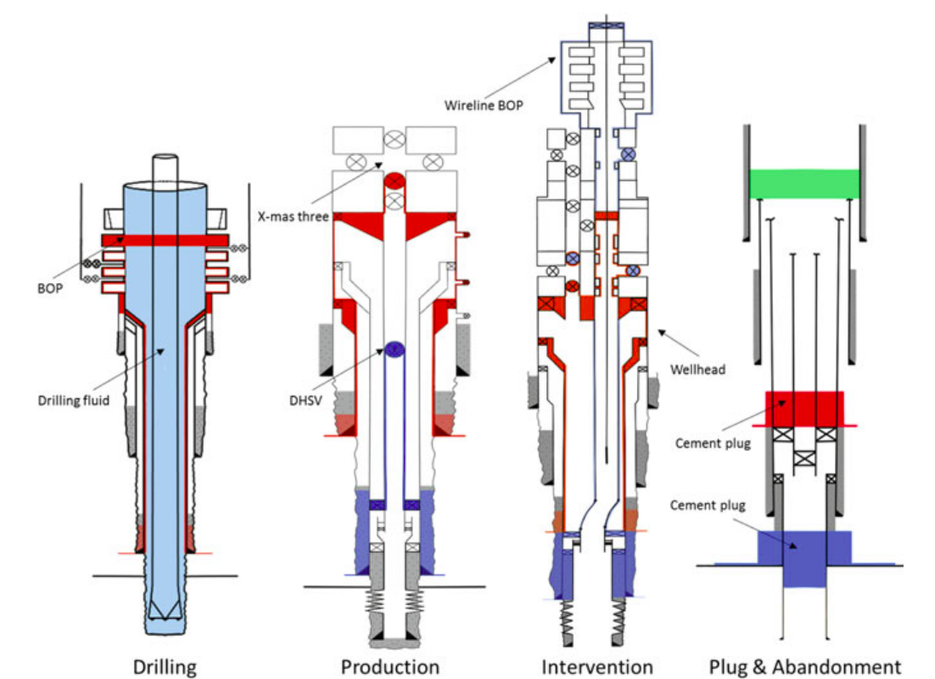

**Figure 4.1: illustration of two barrier concept throughout a well’s lifecycle**

During the permanent Plugging and abandonment During operation, a supplemental plug is used in addition to primary and secondary barriers to get close to the surface. It is commonly referred to as the Environmental plug because it is the shallowest well obstruction that isolates open hole annuli from the outside environment.

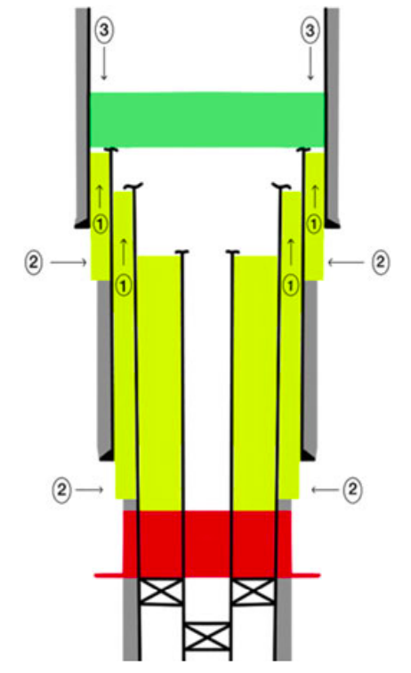

|  |
| --- |
| ‘Functions of an Environmental Barrier’ |
| 1. ‘Preventing the surrounding environment from being exposed to dangerous fluids in various annuli’. |
| 1. ‘Minimizing the potential leak from the unidentified sources close to the surface.’ |
| 1. ‘Swabbing fluid from sea or near surface fresh water in the formation through the created annuli is minimized’. |

**Figure 4.2: Functions of the Environmental barrier shown here in green color**

**4.1.1 Potential leak paths in plugged and abandonment wells.**

Placing cement plugs in a cased wellbore is typically insufficient to stop leaks from the well after abandonment because leaks can also happen outside the casing and in the annulus, particularly in older wells where the cement in the annulus is more likely to be damaged by forces during regular well operation such as pressure testing, injection stimulation, and production disconnectingthe Christmas tree and assembling blowout preventer

Bringing the well to a temporary abandoned condition or shutting it down before starting the permanent P&A operation or after the reservoir abandonment phase is a typical technique. The goal is to lessen the possibility of a kick or discharge of uncontrolled flow while nipping up and down the BOP. The process of removing well-control equipment from the wellhead is known as nipple-down. The procedure of installing well-control equipment on the wellhead is known as nipple-up. This means that having two independent well barrier envelopes is important, as we mentioned earlier in this chapter.



**Figure: 4.3 illustration of two barrier concept throughout a well’s lifecycle**

**4.2 Returning Location to Specified Location:**

The wellhead is evacuated around the surface casing and the casing is cut off below ground after all tubulars have been removed, cement plugs have been installed and tested, and all tubulars have been removed. To avoid further surface exposure of the well, a cap is added, and it is covered. Next, the land is returned to its pre-human state. States may have different rules regarding abandonment. Consult your state's and your community's regulations for the appropriate abandonment procedures.

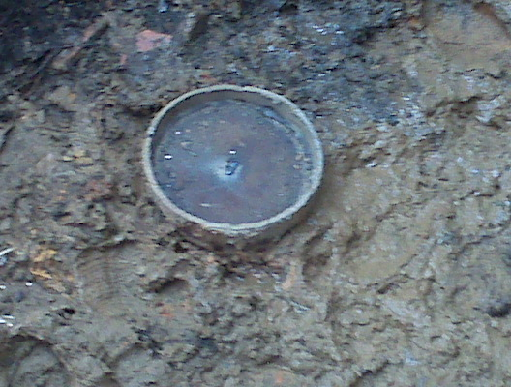

**Figure 4.4: Plugged wellhead**

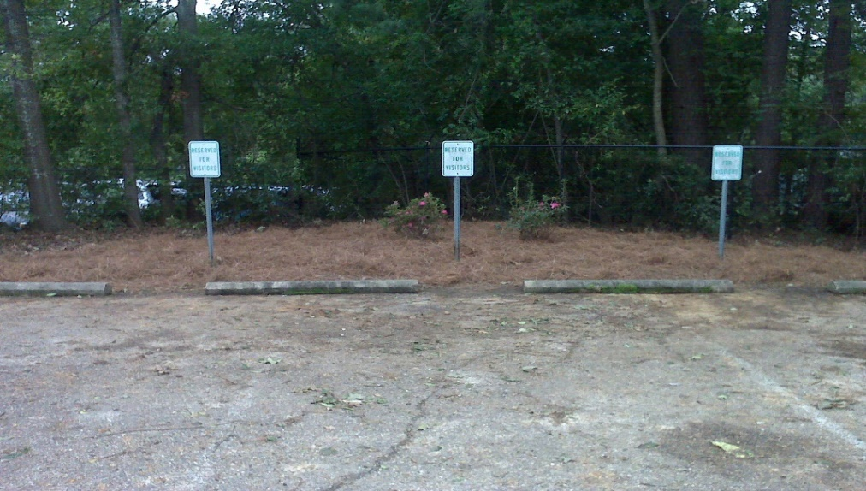

**Figure 4.5: Wellhead location after restoration**

**4.3 After operation:**

1. A workover rig arrives on-site. While the rig is on location, the well will be plugged per the plan. Cement is pumped into the well to cover and isolate the zones that produce oil and natural gas.
2. When the plugging operation is complete, the workover rig moves o­ the location, the well head is removed and the associated flow lines are excavated. Associated surface equipment (tanks, separators, etc.) may also be removed if it is not serving other active wells in the area.
3. The remaining piece of the well is cut at least seven feet below the surface, and the top of the blocked wellbore is welded with an identification marking.
4. To confirm that the wellbore has been filled in line with regulatory standards, a final report is delivered to the company.

.

**Chapter No.# 5: Conclusion and References**

* This Thesis Research Work shows several best practices for establishing of placement of permanent reservoir isolation barriers with CTUPrior to carrying out more difficult procedures like recovering or installing flow control devices, the Gauge Cutter must reach the specified depth to verify that the tubing string is clean.
* Effective cleaning of the well before cementing is essential.
* Effective cement-barrier placement was best provided by a cement slurry designed for both abandonment and placement by means of CT. For CT applications, low viscosities combined with low pumping rates were optimal.
* The use of a regular CT crew together with a mechanic maximizes uptime and improves service quality and safety. Effective CT-string management is important in extended CT campaigns. Real-time data acquisition and analysis and management of fatigue points are vital.
* The industrial requirement to filling old wells or boreholes would be to recover the hydrogeological properties of the site and avoid contaminates or groundwater bacterial contamination.
* Plugging and abandonment processes are carried out at the end of a well's useful life to ensure to maintain formation integrity, by correctly plugging wells, to avoid future environmental problems and soil contamination in a cost effective manner by means of CT.